Trends in Periodic Table
Name: |  |  | Use in Conjunction with class powerpoint
Class: |  |  | Nelson Textbook: pp: 119-122
Period: |  |  | Review Questions 1.5
Date:
Trends in Periodic Table
Multiple Choice
Carefully read each question and then circle the letter of the correct answer.
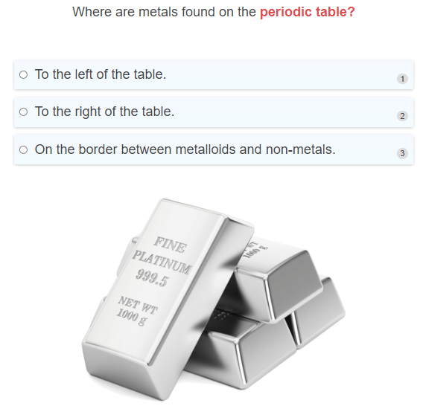
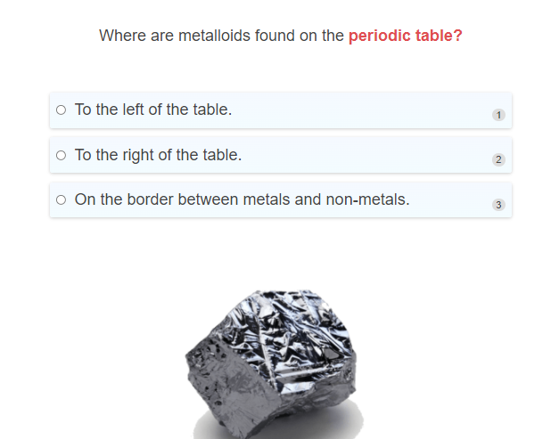
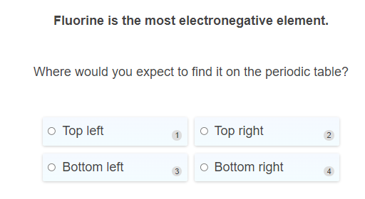
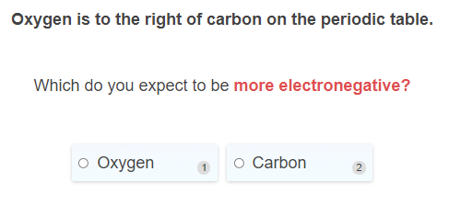
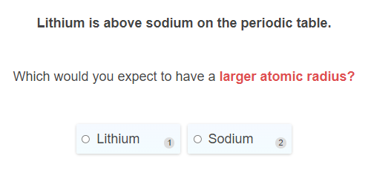
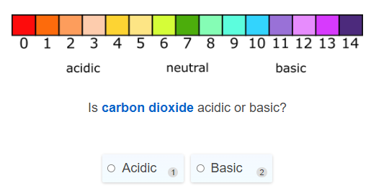
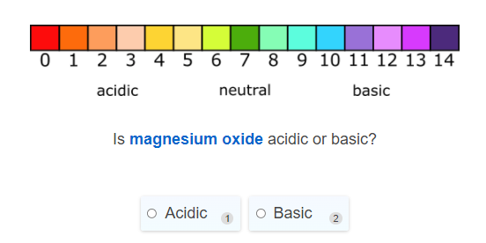

Short and Long Answer
- Select the correct words to fill in the spaces below.
Metals metalloids non-metals
The periodic table is divided into three categories:
The _____________ on the left.
The ______________ on the right (plus hydrogen).
The ______________ on the border between metals and non-metals.

- Explain how to identify on the periodic table if an element is a metal, metalloid or non-metal. Briefly describe one property of metals and non-metals.

- Select the correct words to fill in the spaces below.
atom attracts electrons inner electrons electron attracts atoms outer electrons
Electronegativity is a measure of how strongly an _______________.
Atomic radius is the distance from the nucleus to the ________________.

- Select the correct words to fill in the spaces below.
Increases right to left left to right decreases
Electronegativity increases as you go from _______________ across the periodic table, and ______________ as you go down the table.
Atomic radius increases as you go from _______________ across the periodic table, and _________________ as you go down the table.

- Explain why you think electronegativity increases up a group and across a period.
Remember that moving across a period means increasing the number of electrons in the same shell, and moving down a group means filling up the next electron shell.

Periodic Trends: Electronegativity
Multiple Choice
Carefully read each question and then circle the letter of the correct answer.
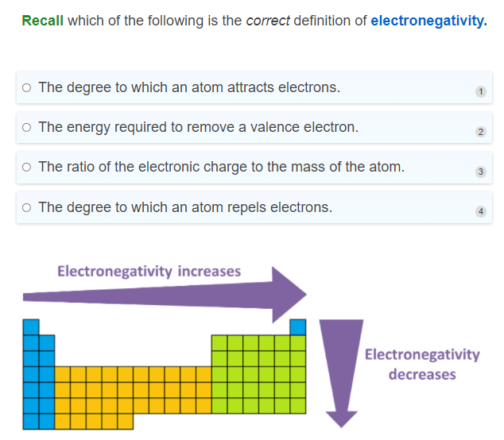
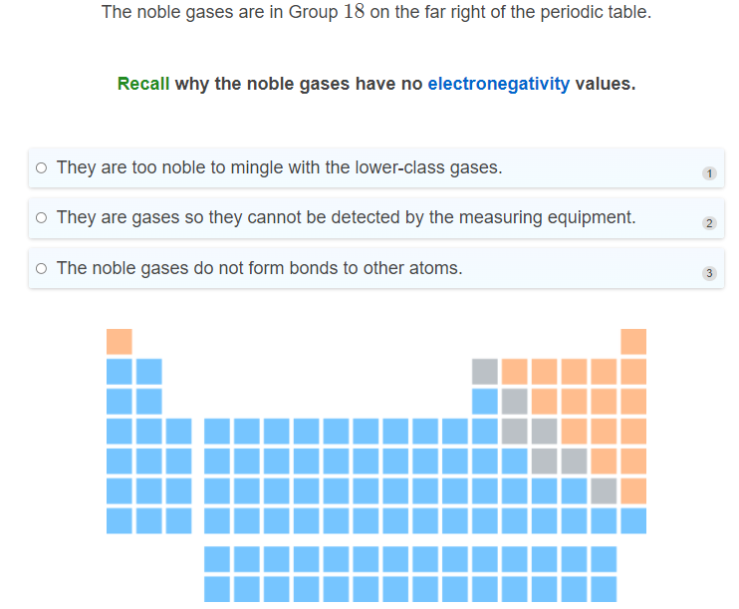
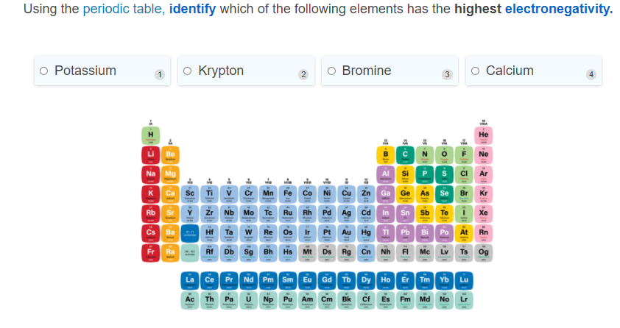
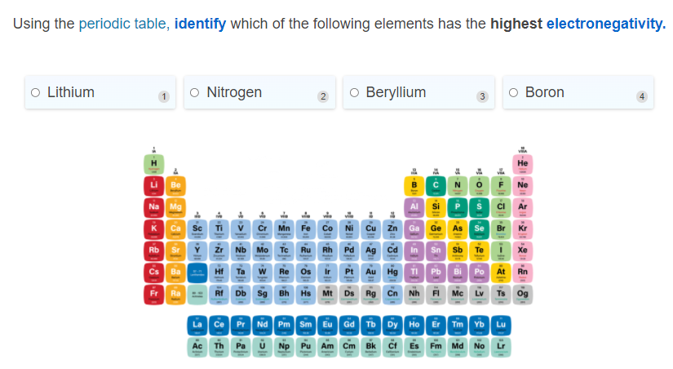
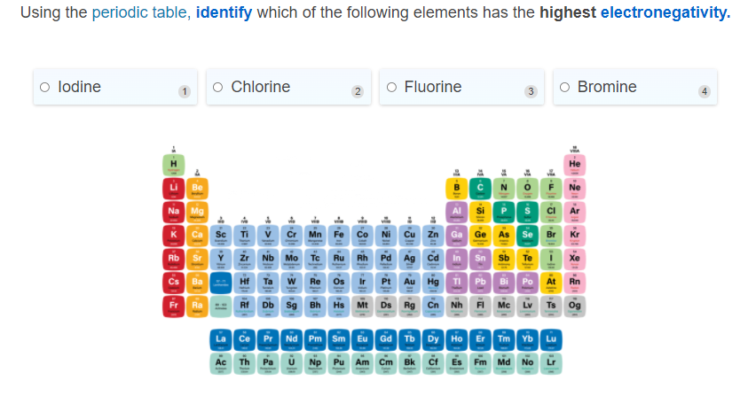

Short and Long Answer
- Using the periodic trends place the following elements in order of increasing electronegativity.
Magnesium Silicon Fluorine Chlorine Carbon
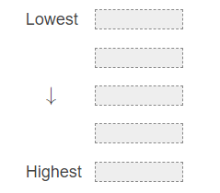

- In your answer make sure to explain what happens to the electron shells and the number of protons in an atom when moving across a period or down a group.

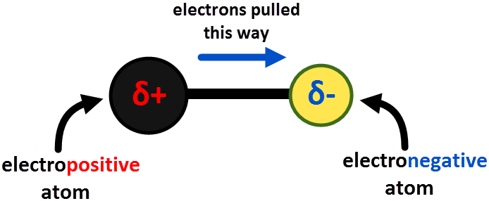

Periodic Trends: Ionisation Energy
Multiple Choice
Carefully read each question and then circle the letter of the correct answer.
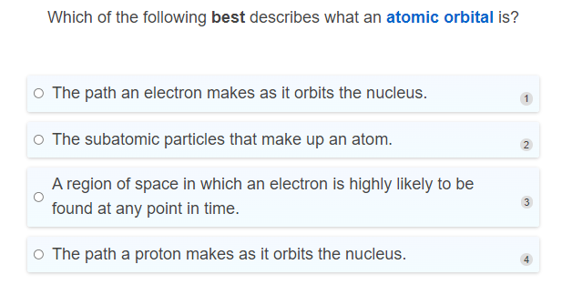
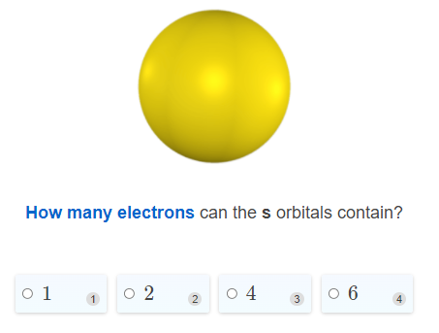
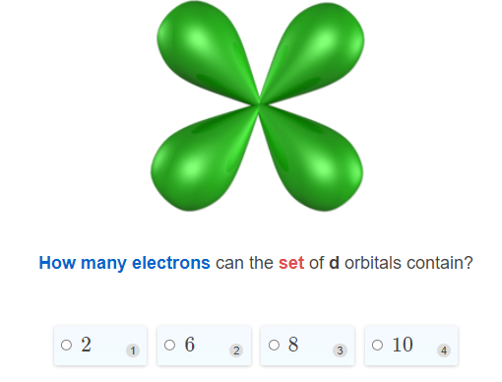
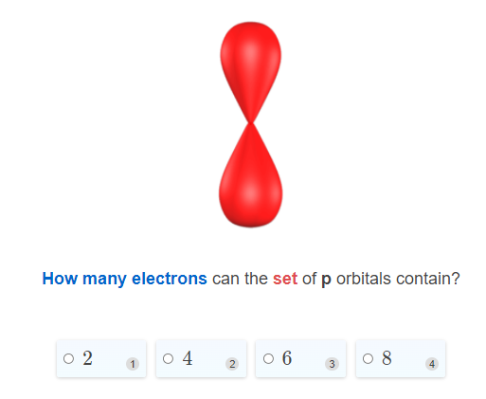
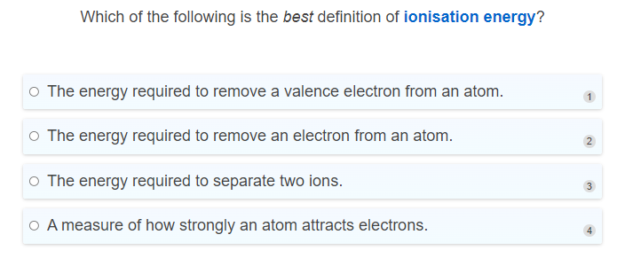
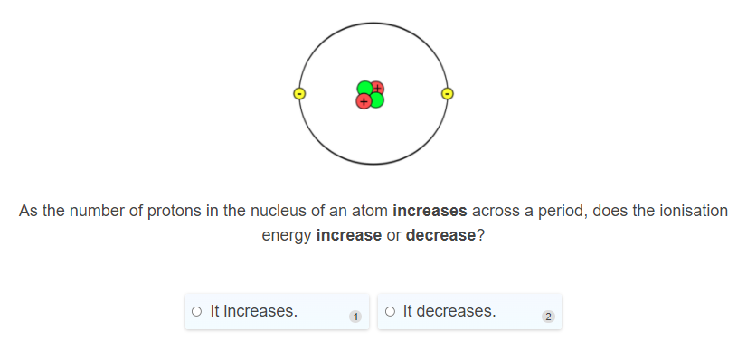
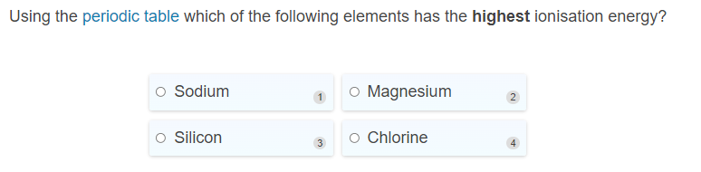
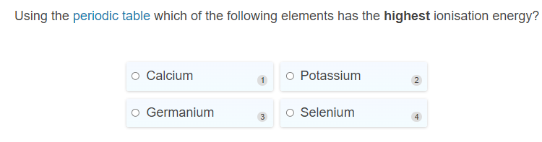
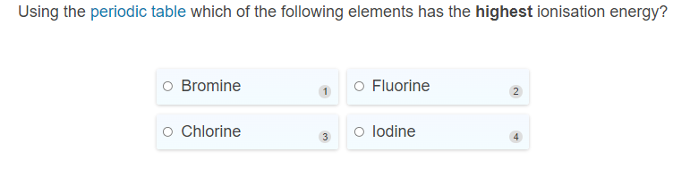
Short and Long Answer
- Metals always react by losing electrons. Metals in group 1 of the periodic table are very reactive, while those in group 2 are less reactive, and those in group 3 are less reactive than both.
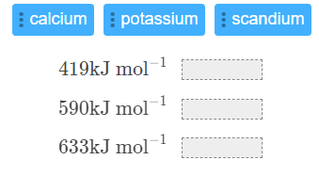
Use this information to match the metals below to their first ionisation energies. Use a periodic table to help you.

- Select the correct words to fill in the spaces below.
Increases weaker attractive force farther stronger decreases

Going across a period ionisation energy ___________________ due to an increased number of protons resulting in _______________ attraction between electrons and the nucleus.

Going down a group ionization energy _____________ due to additional electron shells which place electrons ______________ from the nucleus. A secondary effect is shielding which reduces the ______________ experienced by valence electrons.

- State the periodic trend for ionisation energy and explain why it occurs.

In your answer make sure to explain what happens to the electron shells and the number of protons in an atom when moving across a period or down a group.

- Below is a table showing the ionisation energies of four different elements in kJ mol ⁻¹. The elements are sodium, beryllium, boron, and neon (not necessarily in this order).
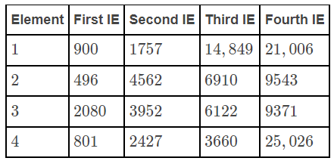

Identify which element is which, justifying your answer in terms of their electron configurations.

Periodic Trends: Metallic Character
Multiple Choice
Carefully read each question and then circle the letter of the correct answer.

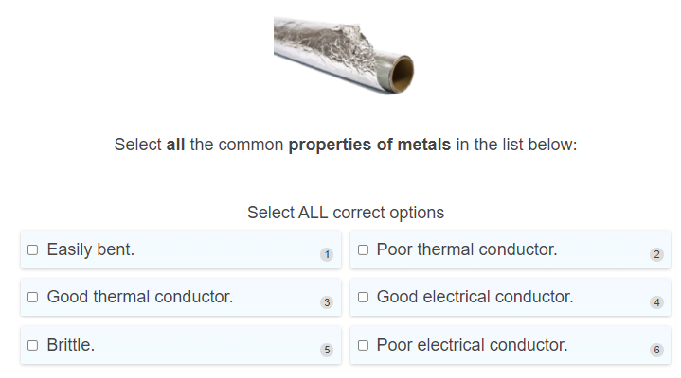
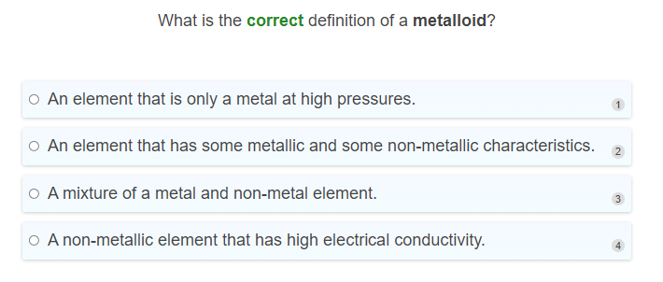
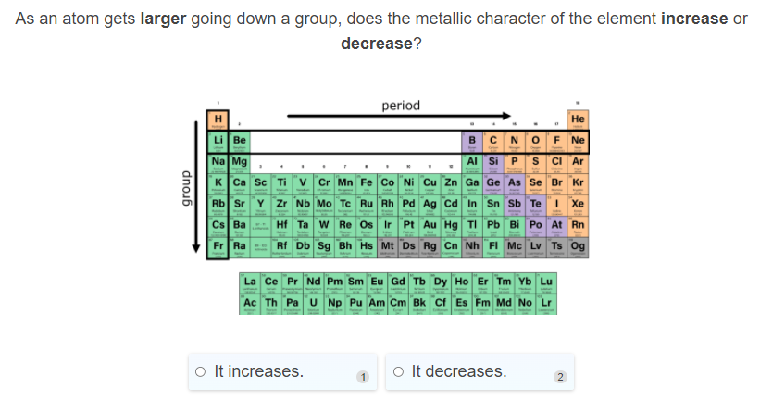
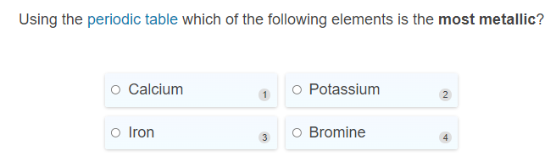
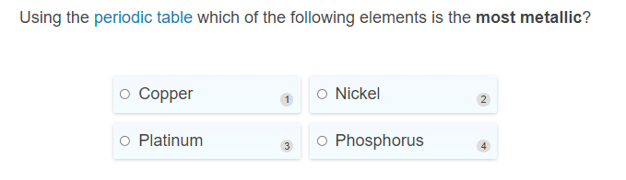
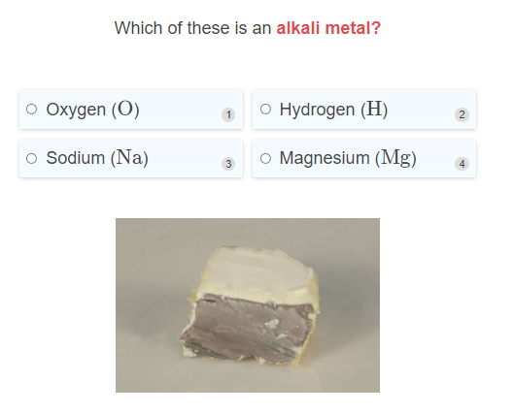
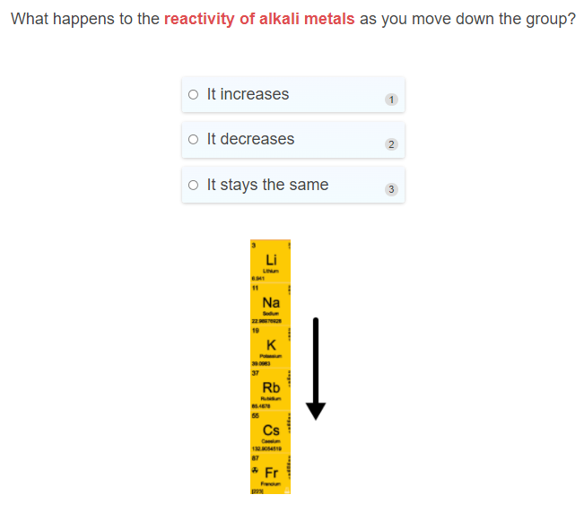
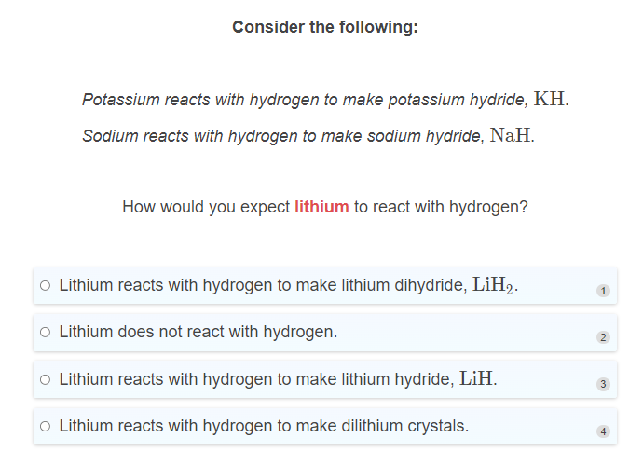
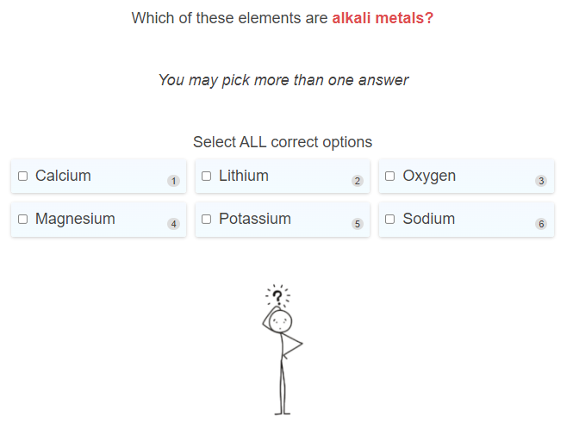
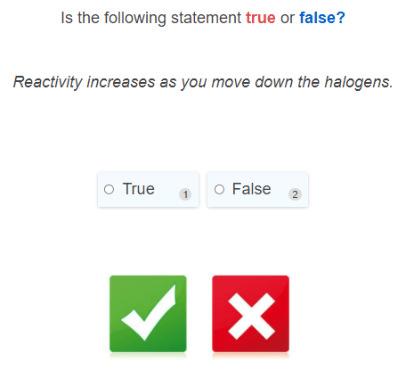
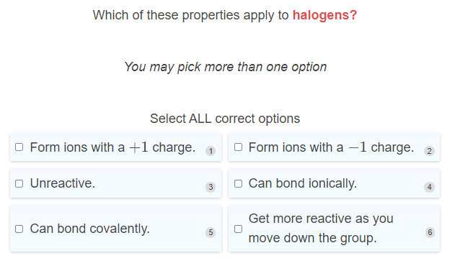

Short and Long Answer
- Select the correct words to fill in the spaces below.
gain increases lose stronger weaker less farther away from more decreases closer to

The metallic character of an element is proportional to its ability to _______________ electrons.

As we move left-to-right across the periodic table the number of protons _______________, this makes the attraction between the electrons and nucleus ______________. Therefore the metallic character of the element __________________.

Moving down a group the valence electrons get _____________ the nucleus, therefore the attraction between the valence electrons and nucleus is less and elements become _______________ metallic.

- State the periodic trend for metallic character and explain why it occurs.
In your answer make sure to explain what happens to the electron shells and the number of protons in an atom when moving across a period or down a group.

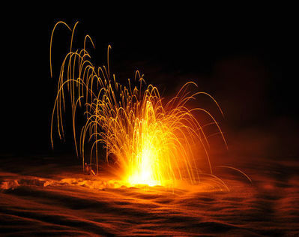
- State the first three alkali metals, and describe the similarities between them.

- State the name of each halogen. Describe the trends in reactivity and toxicity. Do you think these trends are related?
Hint: The chemical symbols are F, Cl, Br and I.

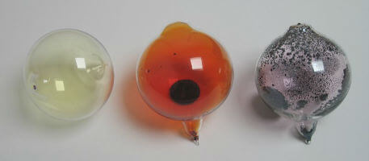

- Describe the trends in melting point, atomic radii, electronegativity and ionisation energy as you move down the halogens, from Fluorine to Iodine.

